A000-AM,C-Taino-Celt-Owl-Basalt-1000 CE

Case no. 18

Owl-like spirit figural ceremonial celt. 10.25 in. long

The Taino ceremonial celt embodied theomorphic themes, suggesting a connection with the realm of the *cemi*. Since the ceremonial celt is rare among the Taino, their ownership was probably restricted to prominent caciques.

These celts are invariably fashioned from very heavy, dense, fine-grained basalt, which makes their surface very smooth when finished. Their subject matter ranges between anthropomorphic spirits to aviform spirits with large concave eyes, perhaps of owls. This suggests that these celts were used in ceremonies invoking the spirits of either deceased ancestors or the nocturnal, all-seeing owl.

Intricate detail on the heads of these aviform celts may incorporate a series of concentric circles above the frontal region as in this example suggestive of superior enlightenment as the concentric circle is a symbol for the sun.

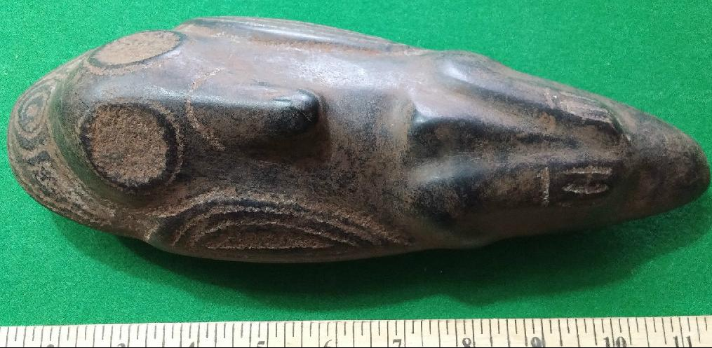 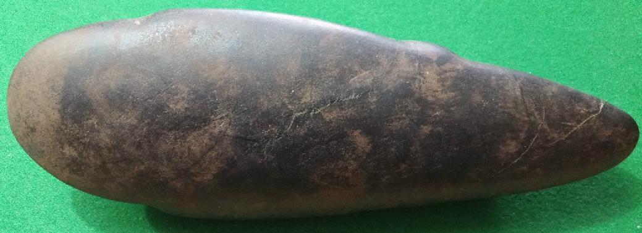 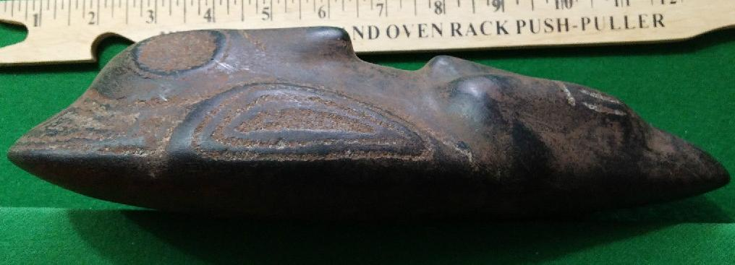

Similarly, the concentric circle may also be transformed into concentric lozenges (as in this example) and may be incised elsewhere, especially on the wings, suggesting the importance of flight, perhaps hallucinogenically induced, to the spirit realm.

Ceremonial celts perhaps originated with the Olmecs (1400-400 B.C.E.) at sites like La Venta , where they depicted their most prominent deity, the god of maize. Post Classic Mayan traders (900-1698) interacted with many peoples of the Gulf of Mexico, probably including the Taino, whom they may have influenced to make their own ceremonial celts since Mayan ceremonial celts were an important part of their religious rites..

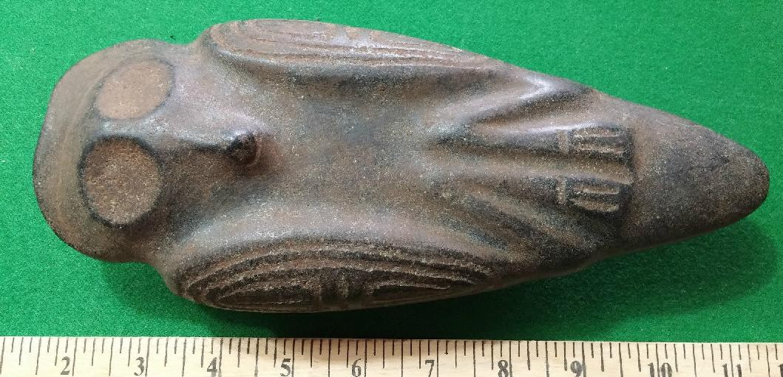

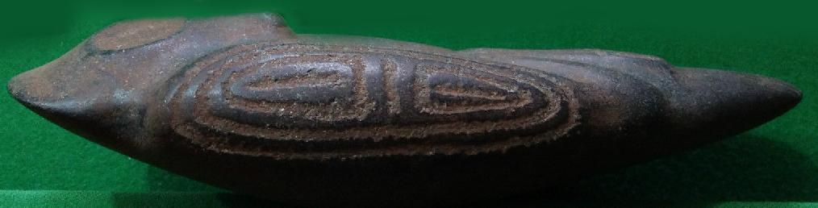

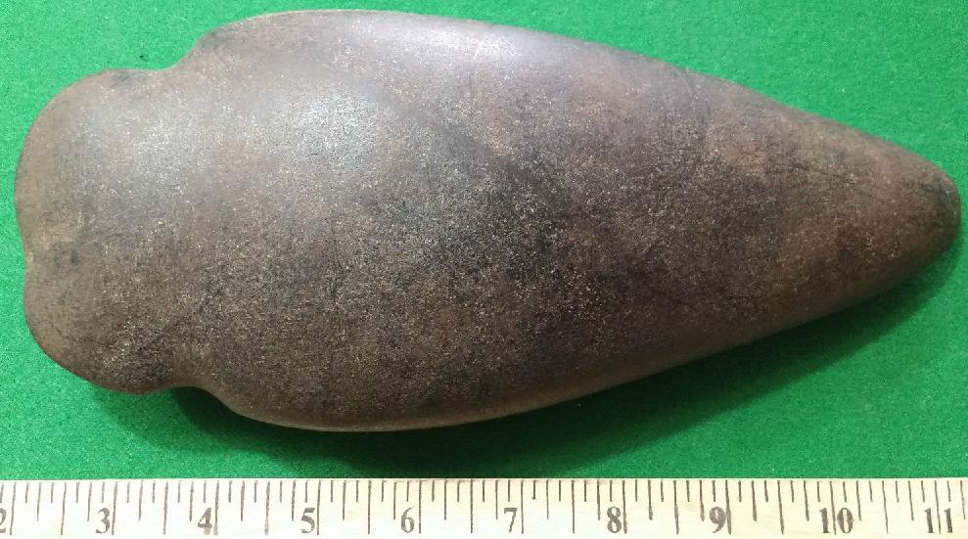

old by [user1billion](http://myworld.ebay.com/user1billion) ( [772](http://feedback.ebay.com/ws/eBayISAPI.dll?ViewFeedback&userid=user1billion) )

### Delivery package 1 of 1

Estimated delivery Wednesday, Dec 23, 2015 - Friday, Jan 1, 2016

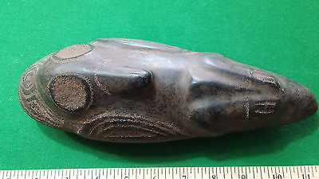

#### [Taino Owl Stone Carving (Idol /Axe Head)- Pre Columbian](http://www.ebay.com/itm/161901981384)

|  |  |
| --- | --- |
| Item price | $339.00 |
| Quantity | 1 |
| Item number | 161901981384 |
| Shipping service | Standard Int'l Shipping |

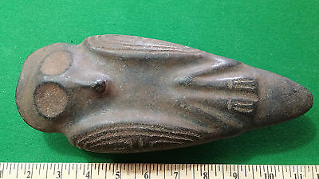

$717.90